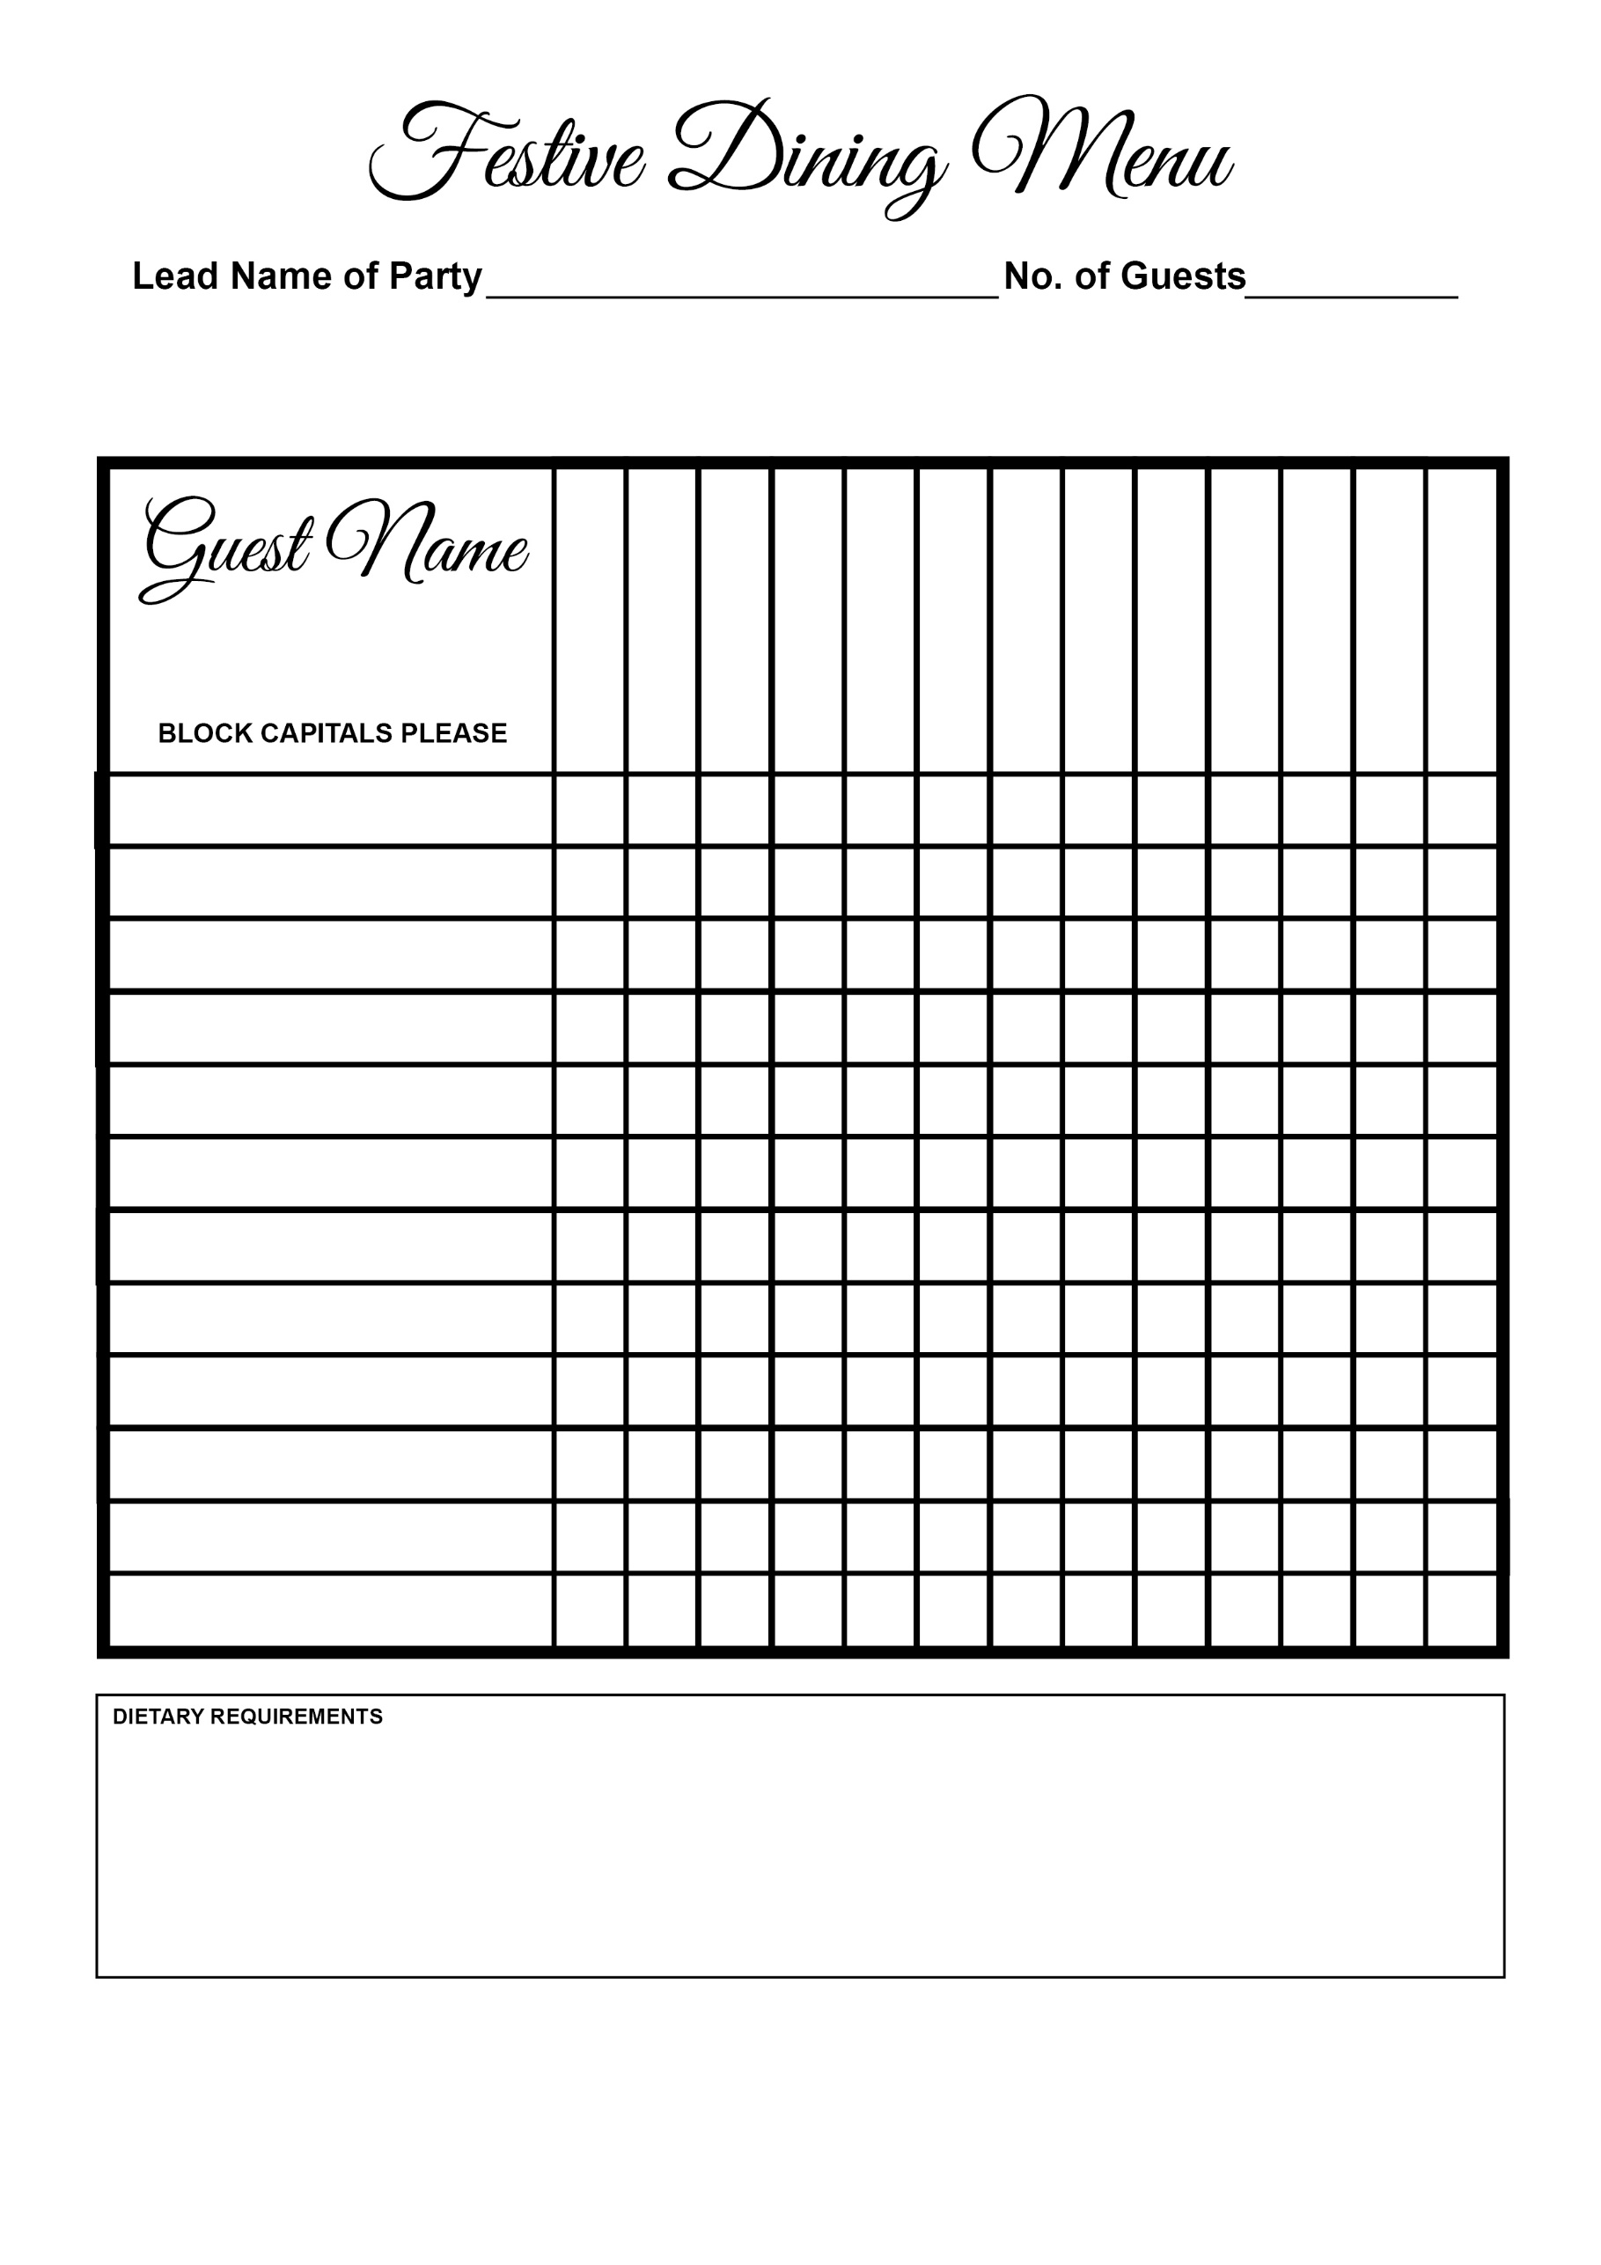

Chocolate Brownie

Christmas Pudding

Blue Cheese Salad

Cheese & Biscuits

Panna Cotta

Pheasant Breast

Risotto

Haddock

Turkey

Duck

Crayfish

Soup